CO4 – QUESTION 4
Geographical Pattern and Correlation Analysis

1. Aim
To analyze geographical and demographic data, join datasets, identify correlations between demographic factors and sales, group locations based on performance, detect outliers, and present geographical patterns using suitable visualizations.

2. Dataset Description
Two simple CSV datasets are used for the analysis:
- location_data.csv – contains Location_ID, Location, Population, Income and Customer_Density.
- sales_data.csv – contains Location_ID and Sales.
- A small location-coordinate table is used internally for the geographical visualization.
The datasets are joined using the common Location_ID field.

3. Program Code
import pandas as pd
import matplotlib.pyplot as plt
location = pd.read_csv("location_data.csv")
sales = pd.read_csv("sales_data.csv")
# Join datasets
df = location.merge(sales, on="Location_ID", how="inner")
# Group locations by performance
df["Performance"] = pd.qcut(
df["Sales"], q=3,
labels=["Low", "Medium", "High"]
)
# Correlation analysis
corr = df[["Population", "Income",
"Customer_Density", "Sales"]].corr()
print("Correlation Matrix:")
print(corr)
# Outlier detection using IQR
Q1 = df["Sales"].quantile(0.25)
Q3 = df["Sales"].quantile(0.75)
IQR = Q3 - Q1
df["Outlier"] = (
(df["Sales"] < Q1 - 1.5 * IQR) |
(df["Sales"] > Q3 + 1.5 * IQR)
)
print("\nCombined Dataset:")
print(df)
# Sales chart
plt.bar(df["Location"], df["Sales"])
plt.xticks(rotation=45)
plt.xlabel("Location")
plt.ylabel("Sales")
plt.title("Sales by Location")
plt.tight_layout()
plt.show()
# Correlation visualization
plt.scatter(df["Income"], df["Sales"])
plt.xlabel("Income")
plt.ylabel("Sales")
plt.title("Income vs Sales")
plt.show()

4. Analysis
- The two datasets are joined using Location_ID.
- Locations are grouped into Low, Medium and High performance based on sales.
- Correlation analysis is used to study relationships between population, income, customer density and sales.
- The IQR method is used to identify possible sales outliers.
- Bar and scatter plots show the main sales patterns.

5. Output Screenshots
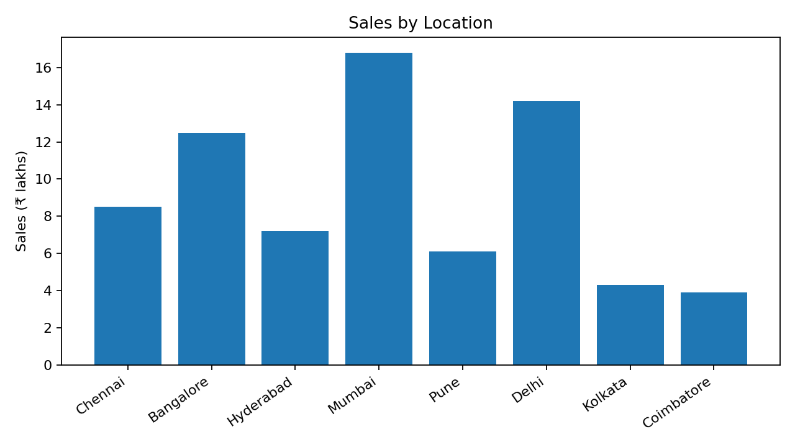
Output 1 – Sales by Location
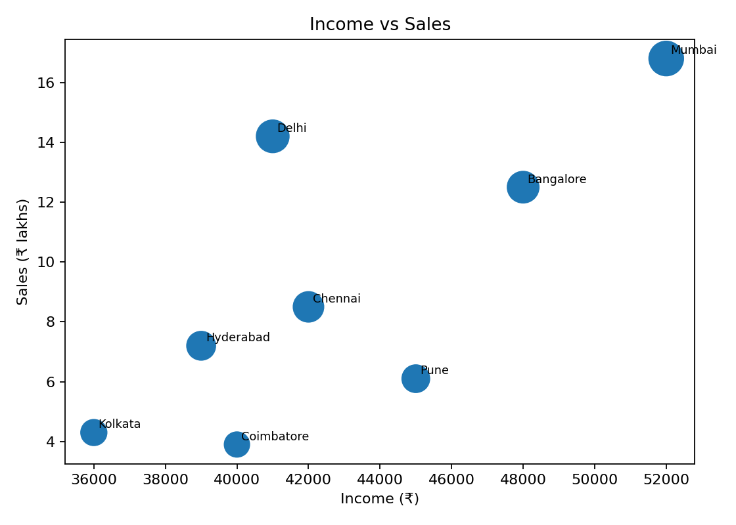
Output 2 – Income vs Sales
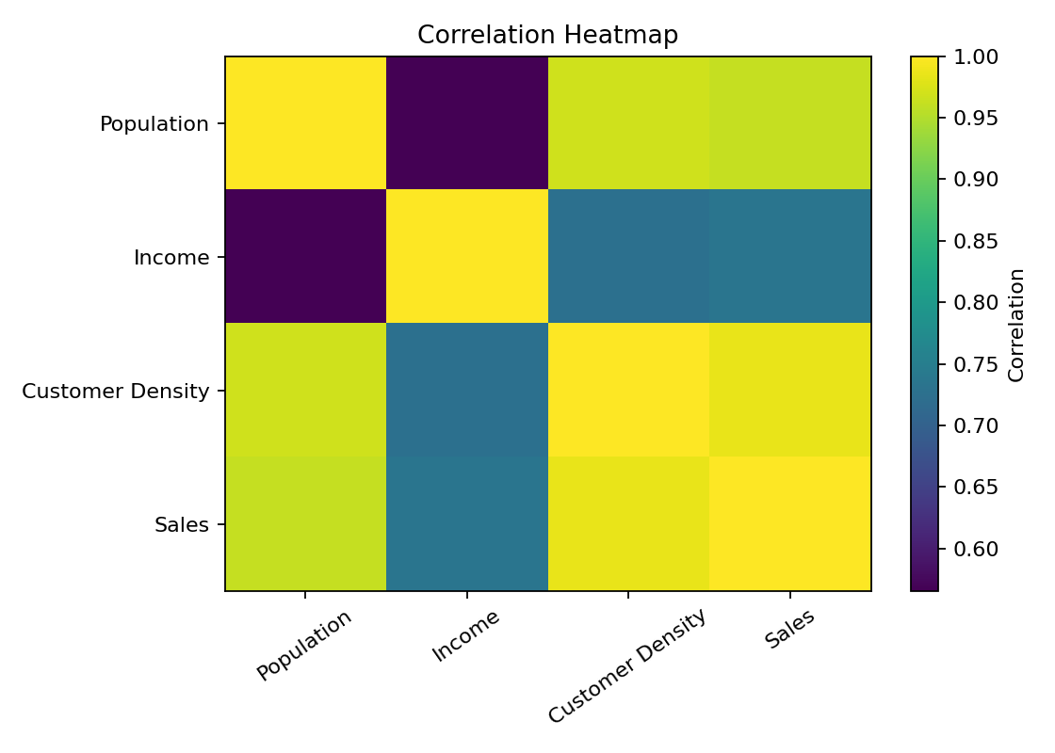
Output 3 – Correlation Heatmap
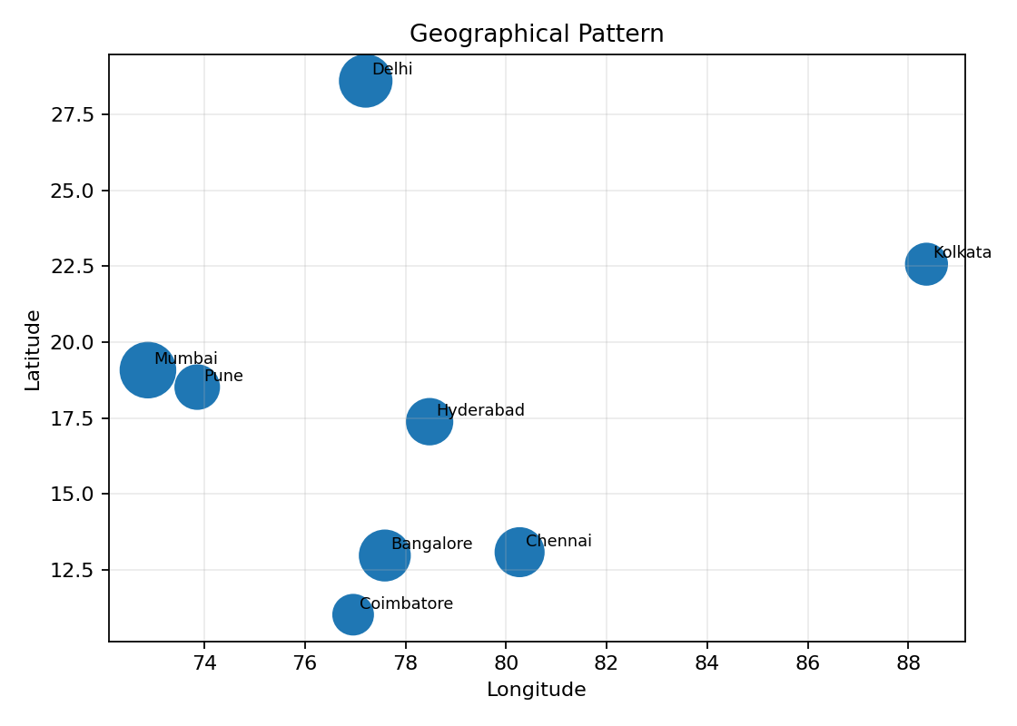

6. Observations
- Mumbai and Delhi show the highest sales in the sample.
- Bangalore also performs strongly because of relatively high income and customer density.
- Customer density and sales show a positive business pattern.
- The geographical visualization makes location-wise differences easy to identify.

7. Result
The geographical pattern and correlation analysis was successfully completed by joining datasets, grouping locations, identifying correlations and outliers, and presenting the results using charts and a geographical visualization.

CO4 – QUESTION 5
Multi-Dataset Business Pattern Analysis

1. Aim
To import and join customer, product, sales and region datasets, explore table functions, identify correlations and outliers, create meaningful business groups, and analyze high-performing and low-performing segments.

2. Dataset Description
Four simple CSV datasets are used:
- customers.csv – contains Customer_ID, Age and Income.
- products.csv – contains Product_ID, Product, Category and Price.
- sales.csv – contains Sale_ID, Customer_ID, Product_ID, Region_ID and Quantity.
- regions.csv – contains Region_ID and Region.
The datasets are joined using Customer_ID, Product_ID and Region_ID.

3. Program Code
import pandas as pd
import matplotlib.pyplot as plt
customers = pd.read_csv("customers.csv")
products = pd.read_csv("products.csv")
sales = pd.read_csv("sales.csv")
regions = pd.read_csv("regions.csv")
# Join all datasets
df = sales.merge(customers, on="Customer_ID", how="inner")
df = df.merge(products, on="Product_ID", how="inner")
df = df.merge(regions, on="Region_ID", how="inner")
# Calculate sales
df["Sales"] = df["Quantity"] * df["Price"]
# Table functions
print(df.describe())
# Grouping
region_sales = df.groupby("Region")["Sales"].sum()
category_sales = df.groupby("Category")["Sales"].sum()
print("Sales by Region:")
print(region_sales)
print("Sales by Category:")
print(category_sales)
# Correlation
corr = df[["Age", "Income", "Price",
"Quantity", "Sales"]].corr()
print(corr)
# Outlier detection using IQR
Q1 = df["Sales"].quantile(0.25)
Q3 = df["Sales"].quantile(0.75)
IQR = Q3 - Q1
outliers = df[
(df["Sales"] < Q1 - 1.5 * IQR) |
(df["Sales"] > Q3 + 1.5 * IQR)
]
print("Outliers:")
print(outliers)
# Charts
region_sales.plot(kind="bar", title="Sales by Region")
plt.ylabel("Sales")
plt.tight_layout()
plt.show()
category_sales.plot(kind="bar", title="Sales by Category")
plt.ylabel("Sales")
plt.tight_layout()
plt.show()

4. Analysis
- The four datasets are joined into one combined business table.
- groupby() is used to identify high-performing and low-performing regions and categories.
- describe() provides summary statistics for the business variables.
- corr() identifies relationships among age, income, price, quantity and sales.
- The IQR method detects unusual sales transactions.
- Charts and the dashboard summarize the discovered business patterns.

5. Output Screenshots
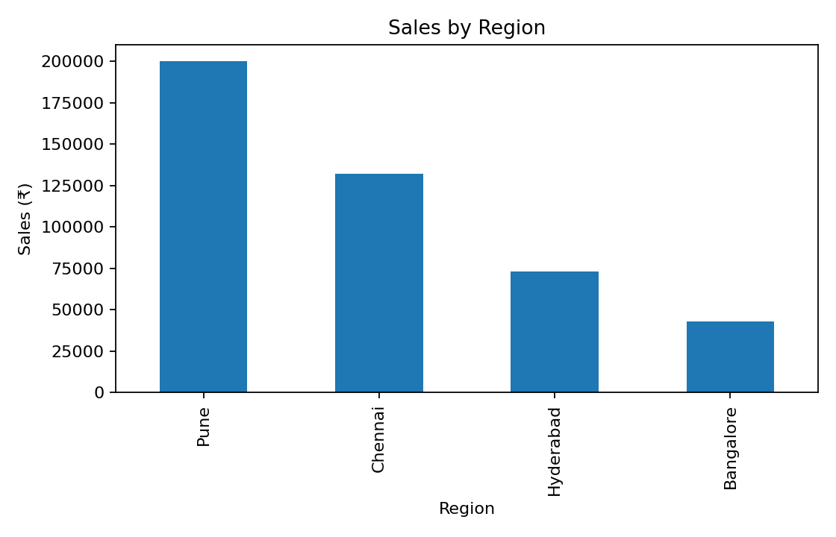
Output 5 – Sales by Region
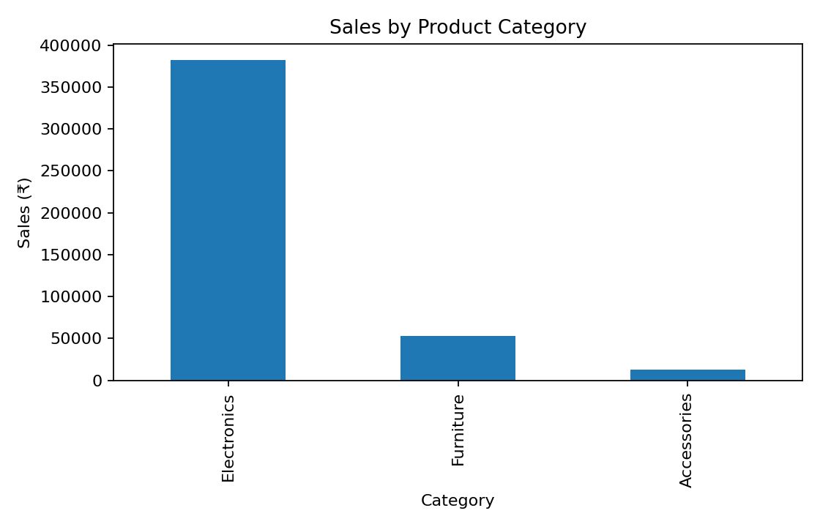
Output 6 – Sales by Product Category
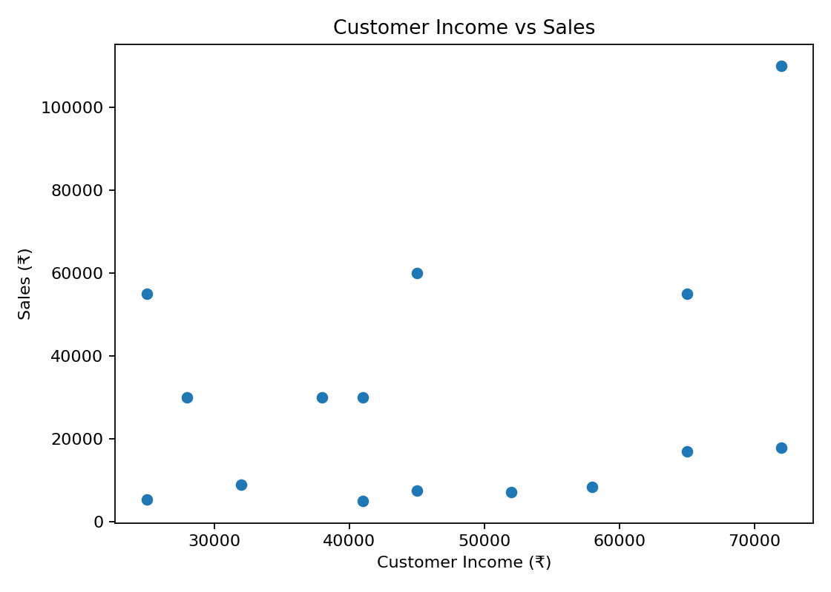
Output 7 – Customer Income vs Sales
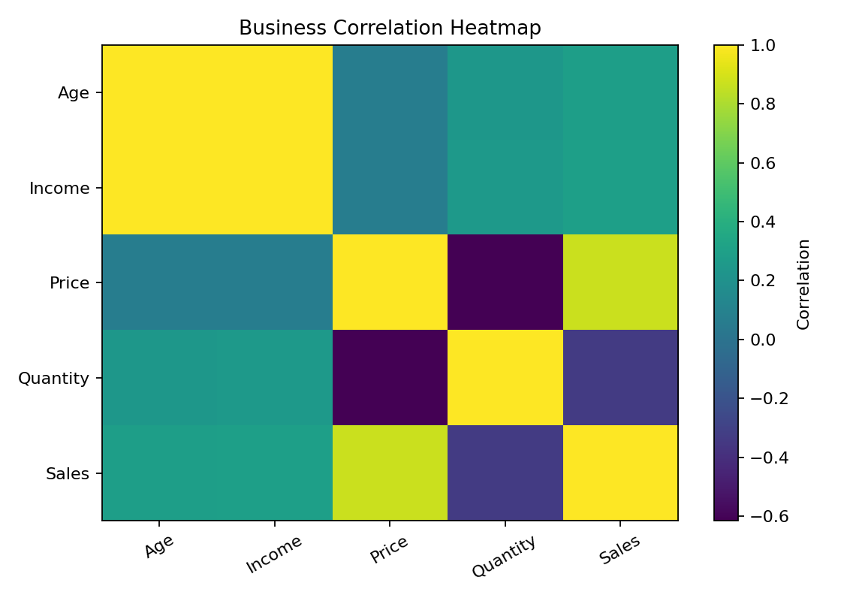
Output 8 – Business Correlation Heatmap
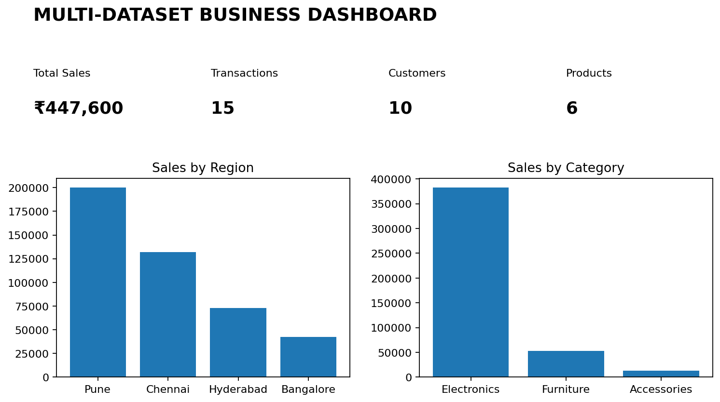
Output 9 – Business Dashboard

7. Observations
- Region grouping identifies the strongest and weakest markets.
- Category grouping shows which product categories generate higher sales.
- Customer income can be compared with sales to identify useful customer segments.
- Correlation analysis reveals relationships between business variables.
- Outlier detection helps identify unusually large or small transactions.

8. Result
The multi-dataset business pattern analysis was successfully completed by joining four datasets, applying table functions, grouping business records, identifying correlations and outliers, analyzing high- and low-performing segments, and presenting the findings through charts and a dashboard.

